# Git Assignment-5

## Create a Git Flow workflow architecture on Git

### **master** → production-ready code

### **develop** → integration branch (base for features)

### **feature/** → feature branches off develop

### **release/** → pre-production branches for testing

### **hotfix/** → emergency fixes branched off master

## Create all the required branches

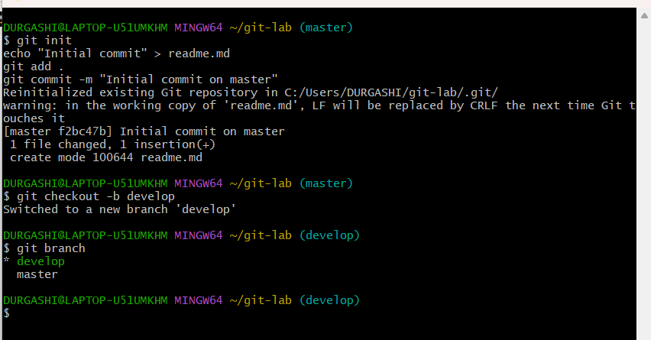

## 3. Starting from the feature branch, push the branch to the master, following

## the architecture

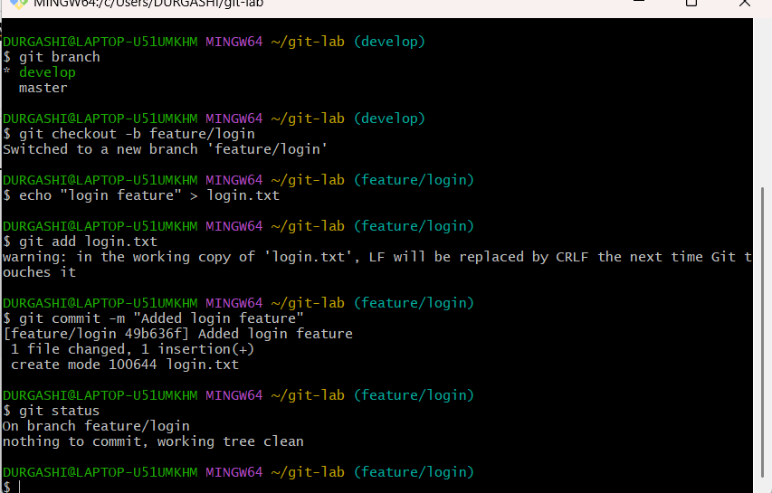

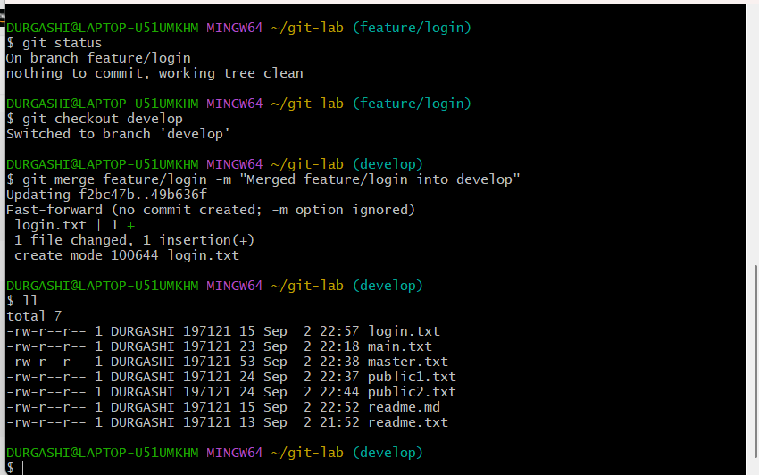

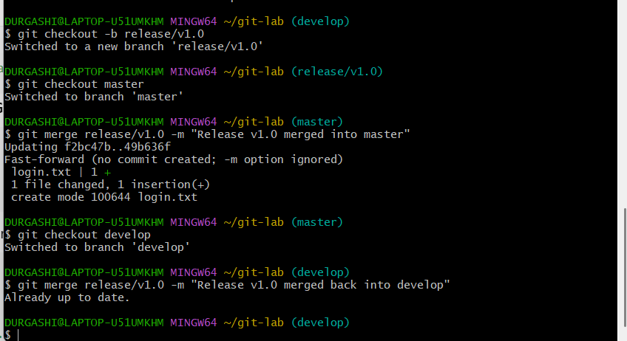

## Push a urgent.txt on master using hotfix

